Quiz 03

Submitted by - Sagar Kukreja

1. We split the train data into test and train data (80/20) and

used cross validation to find the best fit . We found that it is a second degree model as it gives the least error and now we make predictions on the new test input data using the second degree model.

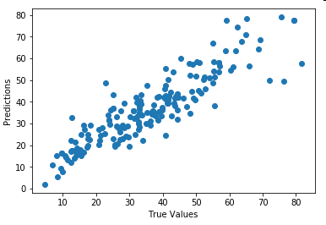

Graph for original and predicted values for original dataset being split into test and train data.